Brian Kiaer

CPE301 – SPRING 2018

Design Assignment 4

**DO NOT REMOVE THIS PAGE DURING SUBMISSION:**

The student understands that all required components should be submitted in complete for grading of this assignment.

|  |  |  |  |
| --- | --- | --- | --- |
| **NO** | **SUBMISSION ITEM** | **COMPLETED (Y/N)** | **MARKS**  **(/MAX)** |
| 1 | COMPONENTS LIST AND CONNECTION BLOCK DIAGRAM w/ PINS |  |  |
| 2. | INITIAL CODE OF TASK 1/A |  |  |
| 3. | INCREMENTAL / DIFFERENTIAL CODE OF TASK 2/B |  |  |
| 3. | INCREMENTAL / DIFFERENTIAL CODE OF TASK 3/C |  |  |
| 3. | INCREMENTAL / DIFFERENTIAL CODE OF TASK 4/D |  |  |
| 3. | INCREMENTAL / DIFFERENTIAL CODE OF TASK 5/E |  |  |
| 4. | SCHEMATICS |  |  |
| 5. | SCREENSHOTS OF EACH TASK OUTPUT |  |  |
| 5. | SCREENSHOT OF EACH DEMO |  |  |
| 6. | VIDEO LINKS OF EACH DEMO |  |  |
| 7. | GOOGLECODE LINK OF THE DA |  |  |
|  |  |  |  |
|  |  |  |  |

1. **COMPONENTS LIST AND CONNECTION BLOCK DIAGRAM w/ PINS**

Components:

* 10K Potentiometer
* 10k Resistor
* Red Pushbutton
* LED
* L293D Chip
* DS2003N/ULN2003 IC
* 5V DC Motor
* Stepper Motor
* Servo Motor
* ATMega328P Explained Mini and ATMega328P Board with Evil Mad Scientist Board.
* **Task 1:**
* 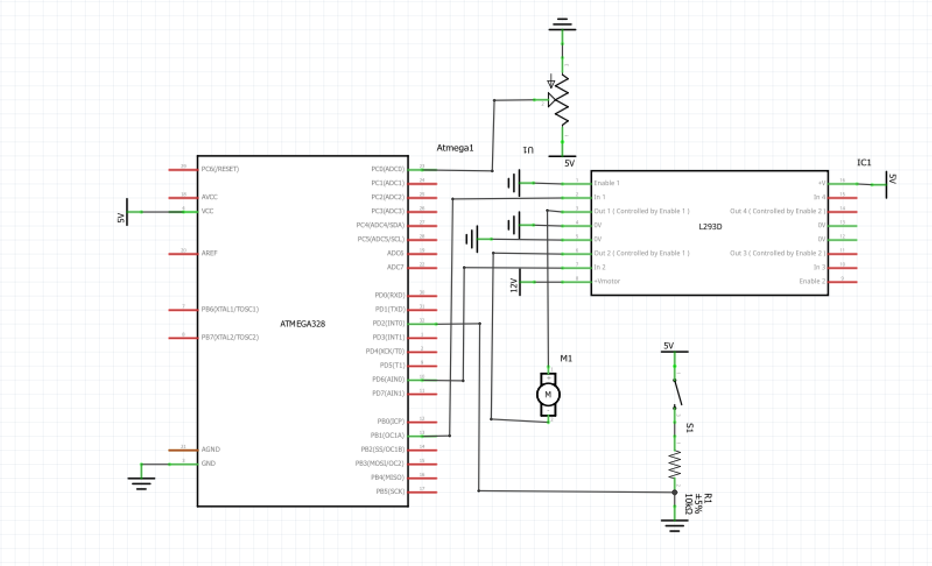
* **Task 2:**
* 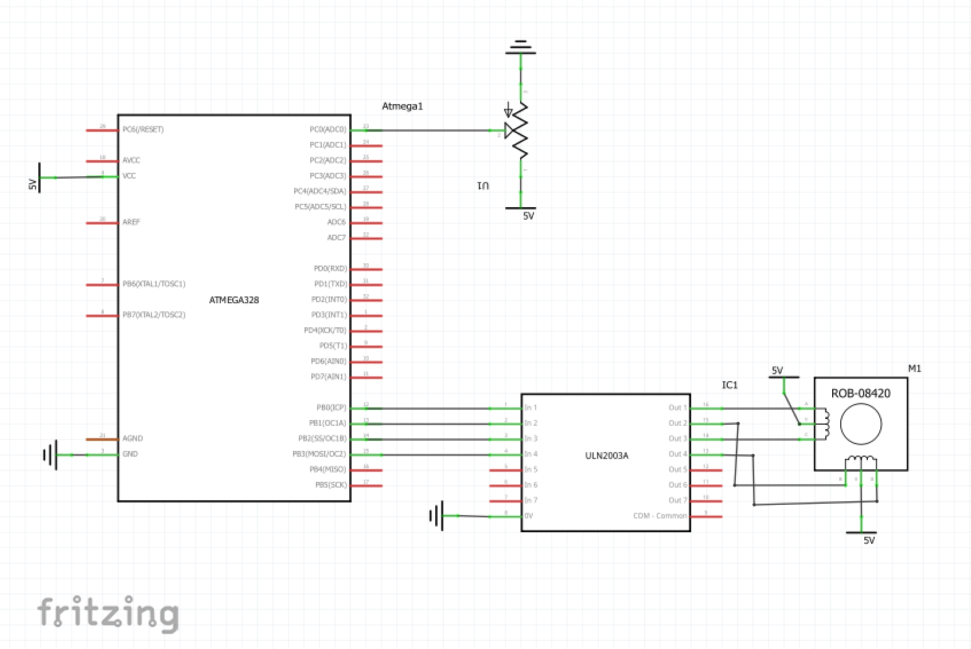
* **Task 3:**
* 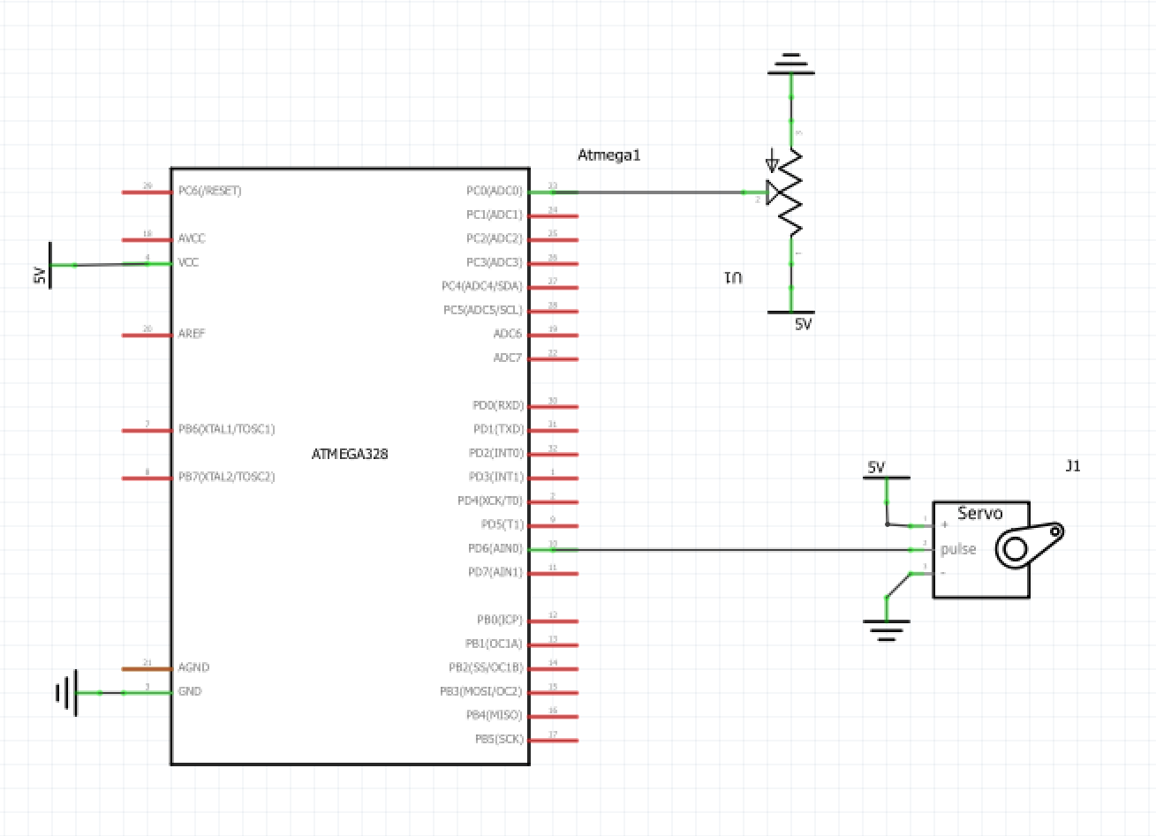

1. **INITIAL/DEVELOPED CODE OF TASK 1/A**

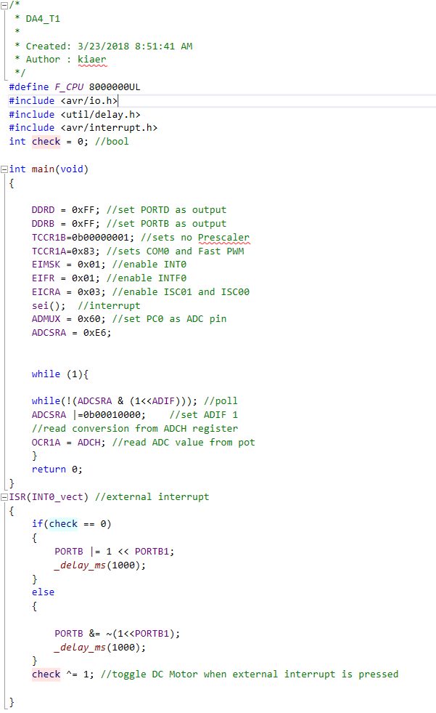

This code above is responsible for implementing ADC with a DC Motor. First, the DC Motor is set to turn on or off whenever a switch/push button has been pressed. Furthermore, the program is responsible for providing ADC values for the DC Motor to change by assigning values via PWM to have the speed change efficiently depending on the potentiometer values.

1. **MODIFIED CODE OF TASK 2**

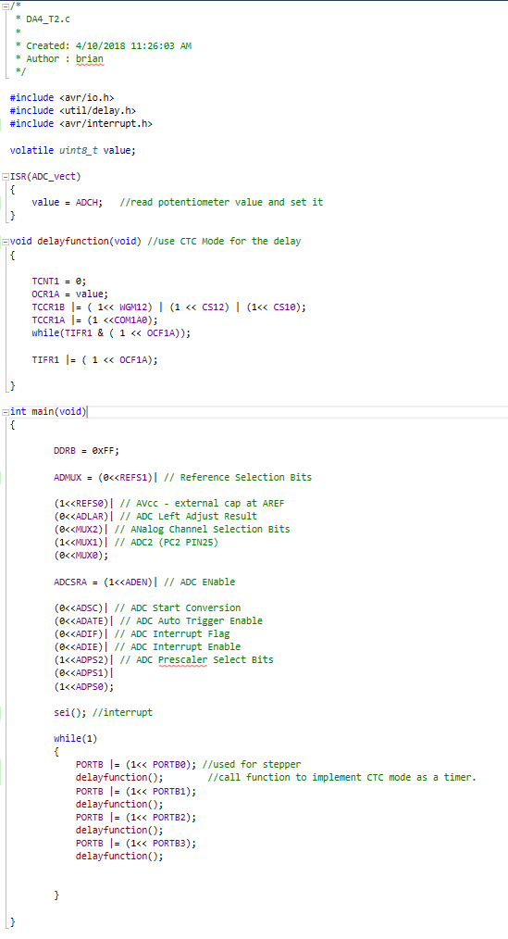

Above is the code for Task 2. This code is responsible for increasing and decreasing the speed of a stepper motor through ADC Conversion. To control the ADC Conversion I used a potentiometer to control the speed. I also used a function to implement delay that was similar to the labs that we used for the stepper motor. The function implements CTC mode for the delay.

1. **MODIFIED CODE OF TASK 3**

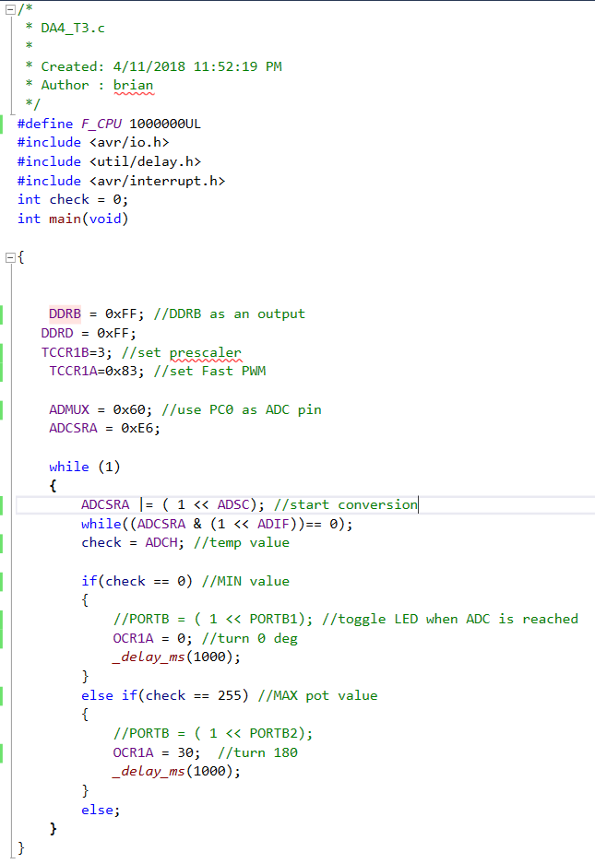

Above is the program written for a Servo Motor for Task 3. This is responsible for rotating the servo motor 180 Degrees when the Potentiometer is at MAX and go to 0 degrees when Potentiometer is at its MIN. I had the program check for the MIN and MAX pot values and set it to turn when it has been reached.

1. **SCHEMATICS**

**Task 1:**



**Task 2:**



**Task 3:**



1. **SCREENSHOT OF EACH DEMO (BOARD SETUP)**

Task 1:

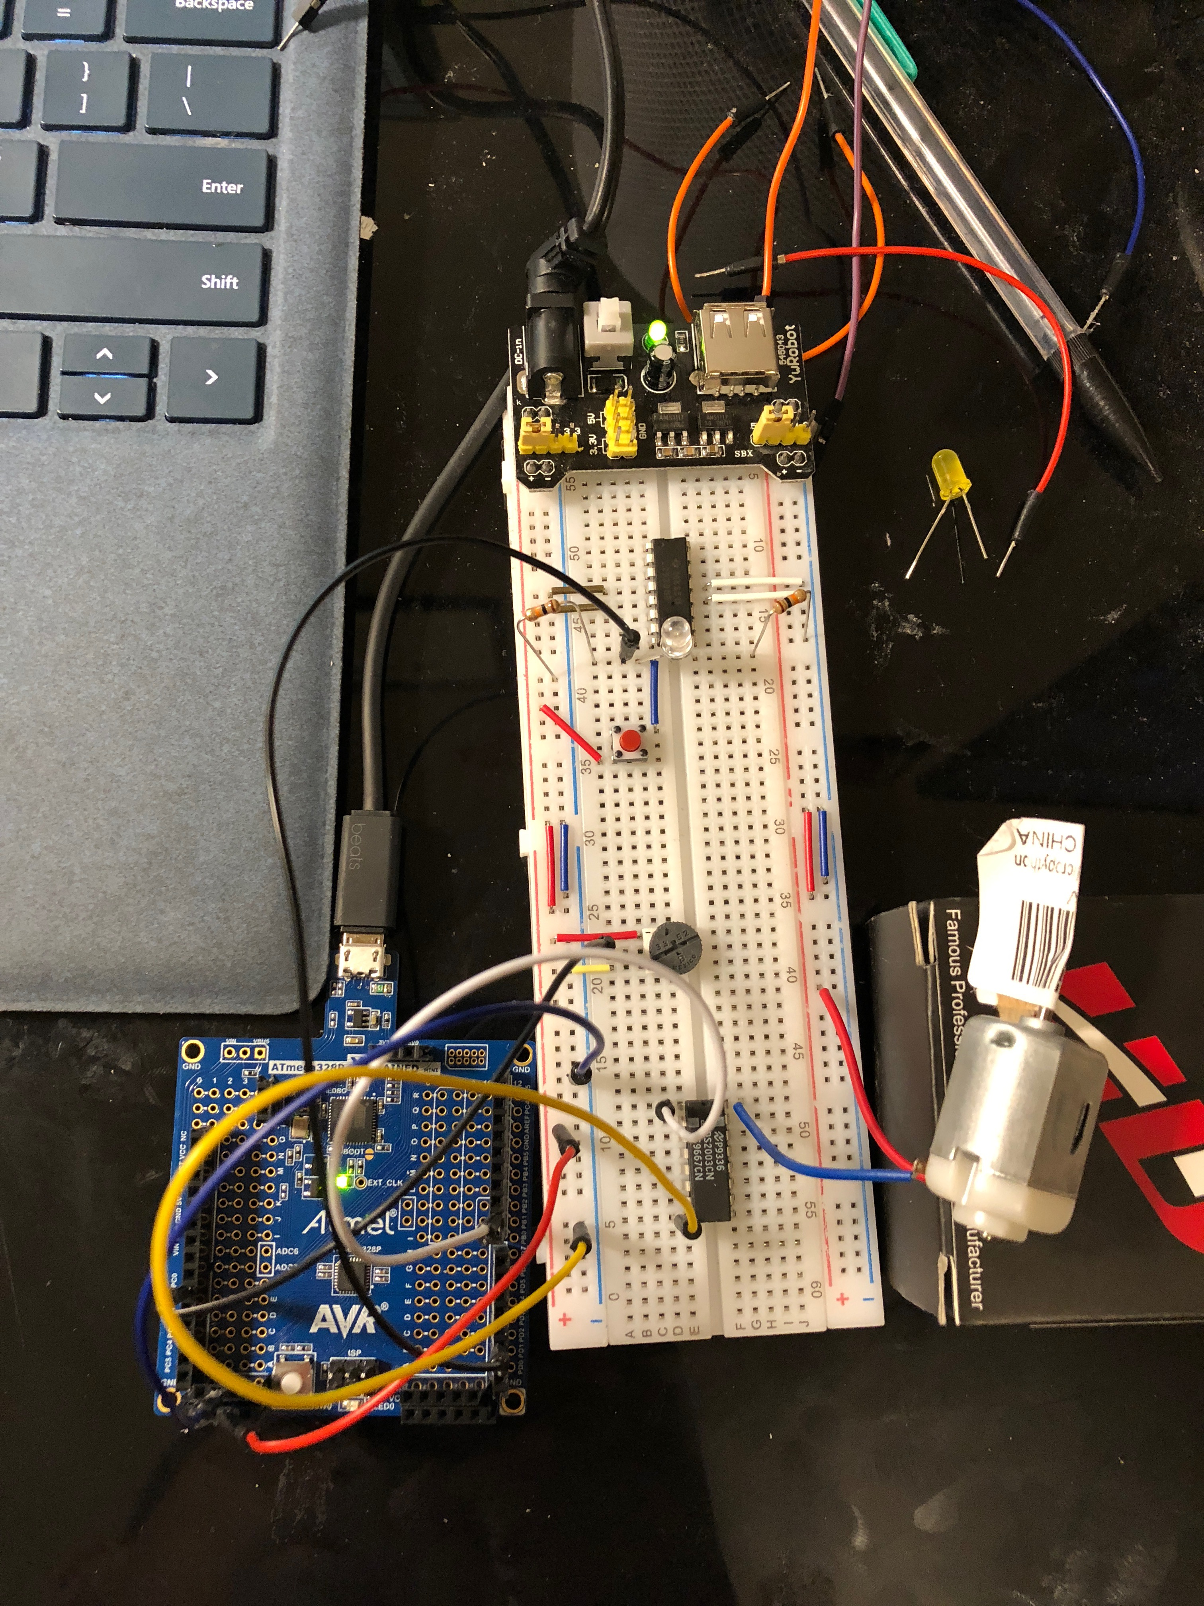 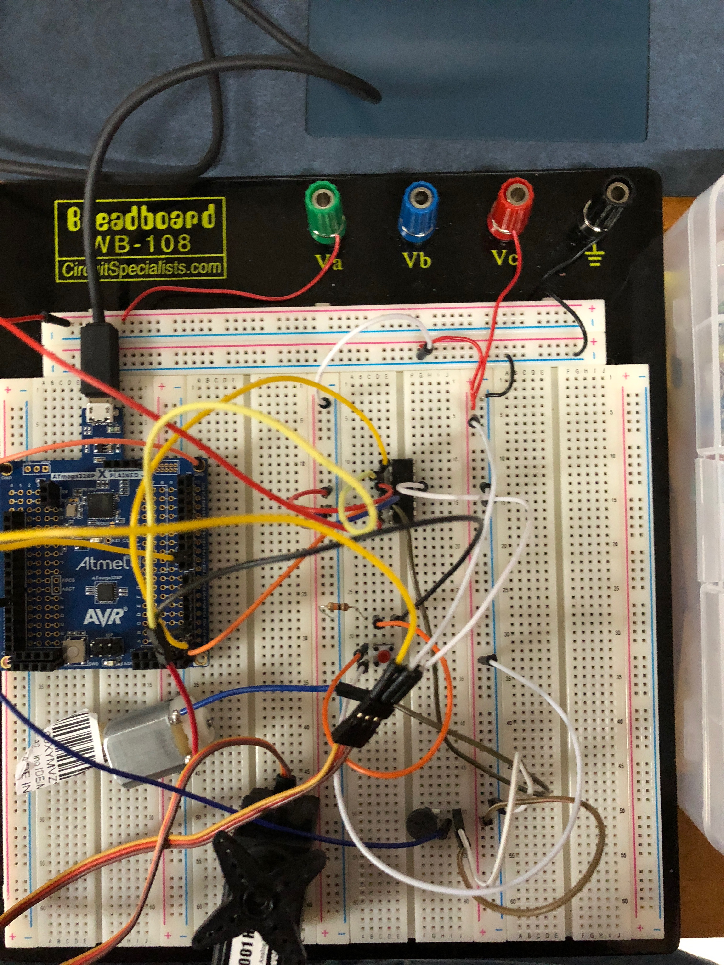

Above is the Board Setup for Task 1. The picture on the left was my original schematic with a DS2003N IC Chip, the issue with this setup was that I could control the device with the Potentiometer; however, I was unable to have the device stop and go when the push button was pressed.

The photo on the right is my improved schematic of the DC Motor. This schematic uses a L293D chip instead which is beneficial because I can send input values to both wires of the DC Motor, which gives me the advantage of changing the direction or having the DC Motor stop when the push button was pressed. I also added a sticker on the Motor to ensure that it was turning. I created the same schematic on the Evil Mad Scientist Board provided in the lab kit.

Task 2:

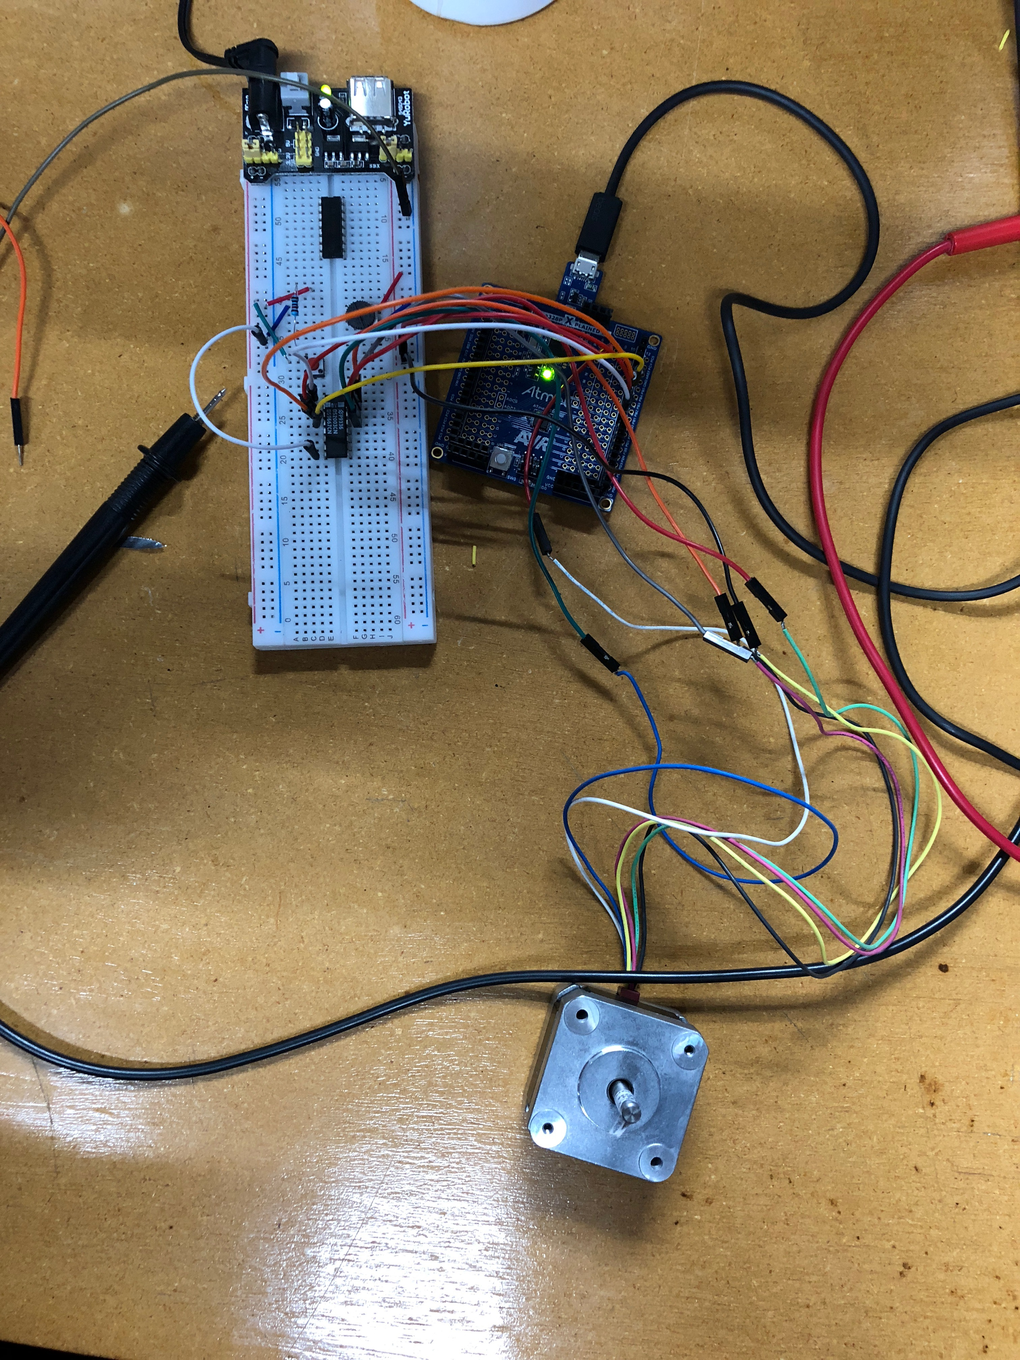 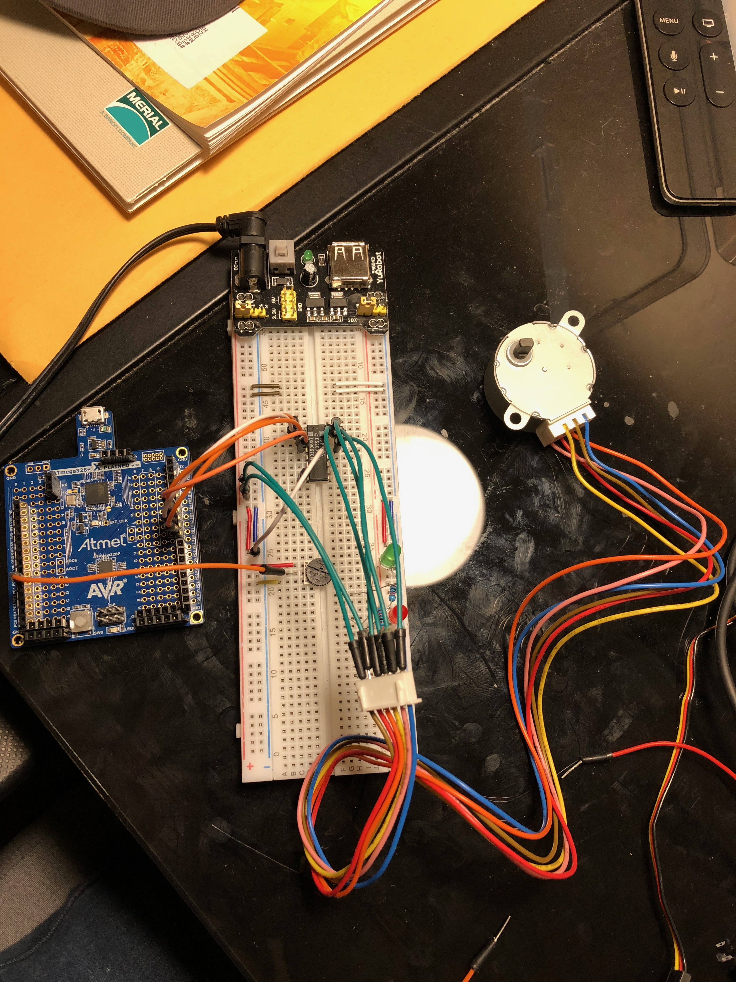

I used two different Stepper motors at home and in the laboratory. This setup uses a Stepper motor that is connected to a ULN2003N IC chip. Furthermore, there is a potentiometer that is connected to PC0 that sends ADC values to alter the speed of the motor.

Task 3:

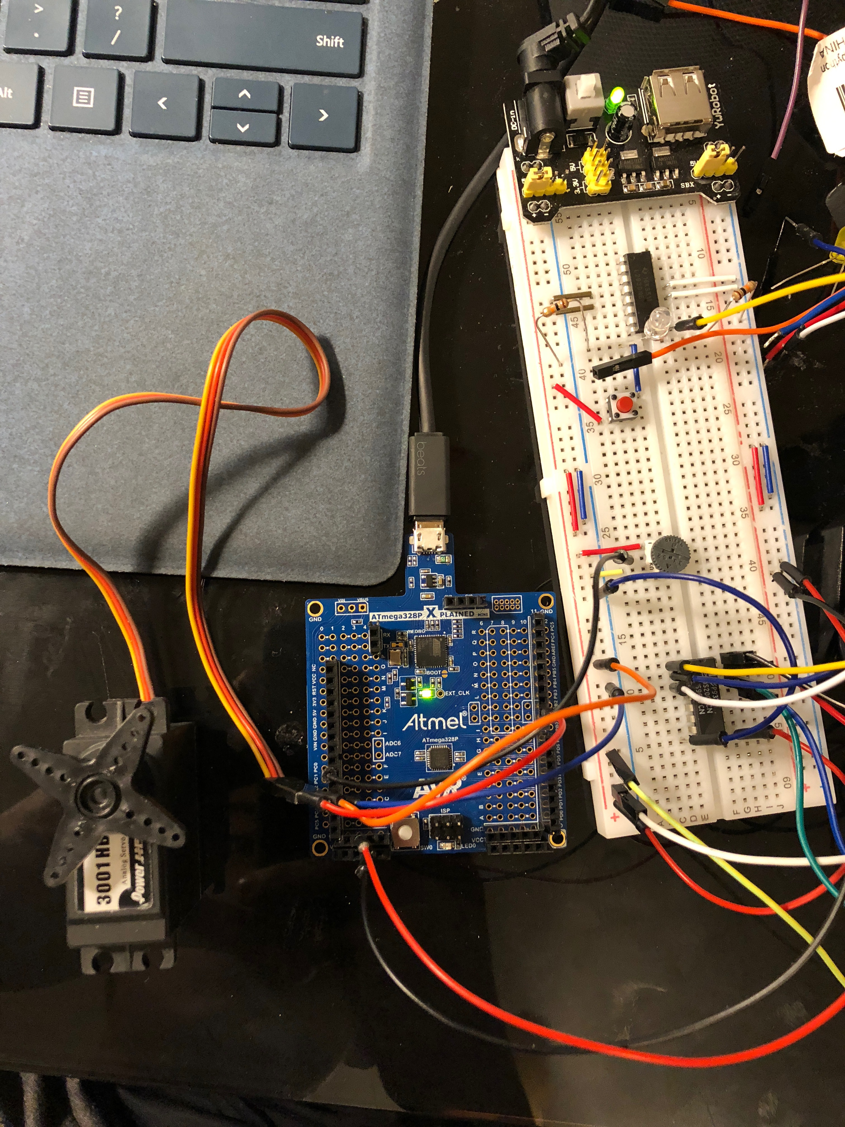

Above is the board setup for Task 3. Connected to the Atmega328P Xplained Mini is a Servo motor and a potentiometer. The potentiometer will have the Motor rotate at 0 degrees or 180 degrees.

1. **FLOWCHART**
2. **VIDEO LINKS OF EACH DEMO**

**Task 1 - https://youtu.be/PrvKxDuE_sg**

1. **GITHUB LINK OF THIS DA**

https://github.com/bkiaer/DA4

**Student Academic Misconduct Policy**

<http://studentconduct.unlv.edu/misconduct/policy.html>

“This assignment submission is my own, original work”.

Brian Medrano Kiaer